PRESS ARTICLE
Conflict sensitivity is key to more effective and timely humanitarian aid
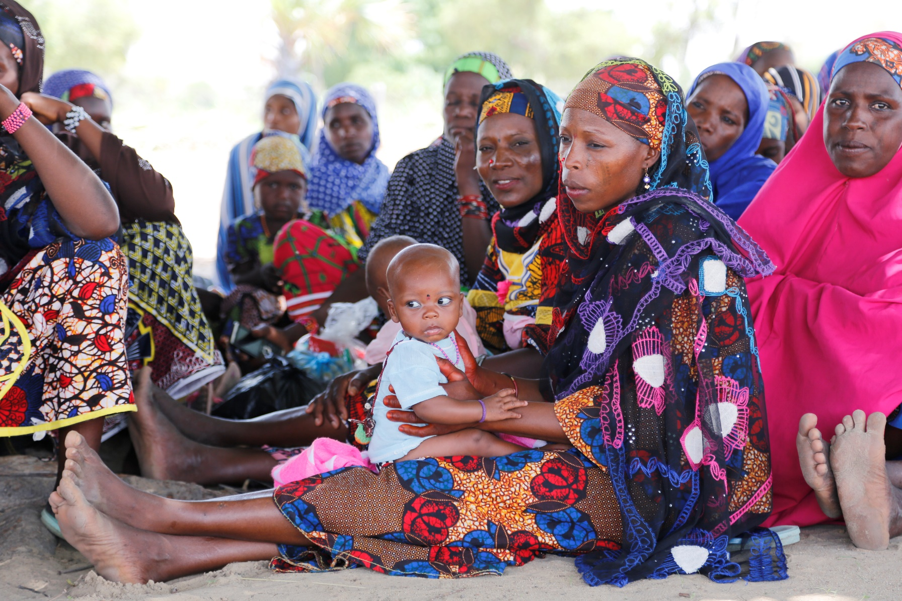
Lessons learned from the Central Sahel

DAKAR, December 2023 – As crises around the world become more diverse and complex, it is increasingly important to be aware of conflict sensitivity. Conflict sensitivity refers to the practice of understanding how humanitarian aid interacts with conflict in a particular context, in order to mitigate unintended negative effects, and to influence conflict positively wherever possible, through humanitarian development and peacebuilding interventions.

One of the most complex and extensive humanitarian crises in the world is the one unfolding in the Central Sahel in Mali, Niger and Burkina Faso. The region is deeply affected by conflict, political instability, climate change, poverty, hunger and record levels of mass displacement. The situation is constantly changing and often in unpredictable ways, making it particularly difficult and challenging for humanitarian organisations to operate. If they don't work with a detailed and comprehensive perspective on the many different factors that make up the crisis, their interventions run the risk of having unintended consequences.
Working holistically paves the way for greater impact
Save the Children and its partners has been working in the region for decades, and we have gradually improved our effectiveness by implementing innovative approaches, in this case the principles of conflict sensitivity. Organisations such as Danish Refugee Council (DRC) and CARE, with whom we are partnering on the ambitious and innovative EU-funded project RECOLG, which has been running since 2019, also implement this approach.

The RECOLG project prevents the most vulnerable and poor people, especially children and women, from extreme poverty, hunger and improves their livelihood and social cohesion through:

- Social protection with cash transfers and health and nutrition services, including mental health and psychosocial support.

- Development and job creation through youth and women’s loan and saving groups.

- Peace building through conflict prevention, mitigation and activities aiming at improving the relations between the population and representatives of the state authorities.

Based on the experiences from the RECOLG project among others DRC has developed the comprehensive report Operationalising conflict sensitivity in complex contexts.

According to the report, it's generally accepted that conflict sensitivity is essential, but its operationalisation remains a key challenge for humanitarian and development organisations. Humanitarian organisations, while upholding and acting in accordance with the principles of humanity, neutrality and impartiality, are often put to the test in challenging environments such as the one in the Central Sahel.

The complexity and volatility of the context, and the underlying cleavages, expose them to a variety of risks, despite their compliance with humanitarian principles. This is why it is essential to understand that aid delivered in a conflict affected environment is not neutral. Aid itself, as well as the way it is delivered, can aggravate tensions or promote peace between communities in conflict.

How to implement conflict sensitivity
Applying a conflict-sensitive approach involves:

- Understanding the context - to have a thorough understanding of the dynamics of peace and conflict in the project's areas of operation.

- Use conflict analysis - to determine what will be monitored and evaluated during the project lifecycle, and how this will be done.

- Use the findings of the conflict analysis - to adapt the implementation approach of an ongoing project, if necessary, or to inform the design of a new project.

By prioritising the principles of doing no harm, understanding local contexts, fostering local capacities, and promoting inclusivity, stakeholders can work towards a more stable and resilient Sahel, where communities thrive and conflicts are effectively managed. This approach acknowledges the agency and resilience of the people of Mali, Niger, and Burkina Faso in shaping their own futures, and it lays the foundation for a more peaceful and prosperous region.

Our ability to implement conflict sensitivity in every aspect of the RECOLG project is one of the main reasons why our work has had such a strong impact despite the difficult circumstances. And since 2019 we have helped and supported more than 750,000 people in the Central Sahel with social protection, development and job creation and peace building. However the need is much greater and unfortunately our programme expires at the end of the year.

That’s why the partner organisations in the consortium are actively fundraising for a new multi-annual phase of the RECOLG project building on lessons learned and adjusting the programming to the ever-changing context in the Central Sahel.

About RECOLG
With funding (18.24 million euros) from the EUTF and DANIDA, we are implementing a Humanitarian, Development & Peace Nexus (HDP Nexus) project in the region of the Liptako-Gourma in the Central Sahel over a period of four years (December 2019 – December 2023) targeting 768,719 beneficiaries.

The project prevents the most vulnerable and poor people, especially children and women, from extreme poverty, hunger and improves their livelihood and social cohesion.

The project addresses humanitarian needs through social protection with cash transfers and health and nutrition services, including mental health and psychosocial support; development through the creation of youth and women’s loan and saving groups; and peace through conflict prevention, mitigation and activities aiming at improving the relations between the population and representatives of the state authorities. Overall, the project aims at building resilience and social cohesion.

CONTACTS
For further enquiries please contact:

Jonas Fruensgaard Ariane Rosenbeck
jofn@redbarnet.dk arro@redbarnet.dk

SAVE THE CHILDREN exists to help every child reach their full potential. Around the world, we make sure children stay safe, healthy and keep learning, so they can become who they want to be.

Can be downloaded her: https://pro.drc.ngo/media/nyfmxas5/op%C3%A9rationalisation-des-analyses-sensible-aux-conflits.pdf

